WEEK 4
Ames Housing Dataset
EDA DEEP DIVE

1. Introduction
Week 4 extends the previous data loading, initial visualization and data-cleaning activities into a deeper Exploratory Data Analysis (EDA). The objective is to understand the distribution of important variables and investigate relationships between housing characteristics and SalePrice.

2. Objectives
- Perform univariate analysis of important numerical and categorical variables.
- Visualize distributions using histograms, KDE plots, boxplots and count plots.
- Perform bivariate analysis using scatter plots and grouped comparisons.
- Study relationships between housing features and SalePrice.
- Use correlation analysis and a heatmap to identify important numerical relationships.
- Document observations that can guide subsequent project analysis.

3. Dataset
The analysis uses the Ames Housing dataset used in Weeks 1–3. The repository's Week 2 analysis records the dataset at 3,130 rows and 82 columns. The Week 3 cleaning notebook records a prepared dataset with zero remaining missing values. The Week 4 notebook is designed to use that cleaned file when it is available.

4. Tools and Libraries
Python was used for the analysis. Pandas and NumPy were used for data handling and numerical analysis, while Matplotlib and Seaborn were used for visualization.

5. Univariate Analysis
Univariate analysis examines one variable at a time. The notebook calculates descriptive statistics and skewness for SalePrice, Gr Liv Area, Overall Qual, Year Built, Total Bsmt SF and Garage Cars.
Histograms with KDE curves are used to inspect the shape of numerical distributions. Boxplots are used to examine spread and potential extreme values. Categorical frequency plots are used for variables such as Neighborhood, House Style, Sale Condition, Sale Type and MS Zoning.
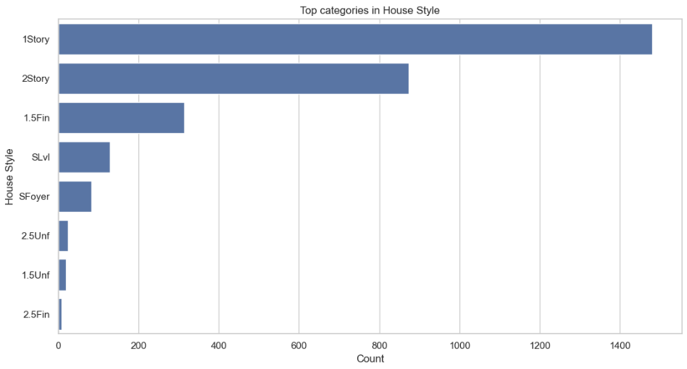

6. Bivariate Analysis
Bivariate analysis examines relationships between pairs of variables. Scatter plots are produced for Gr Liv Area, Total Bsmt SF, Year Built and Garage Cars against SalePrice. Boxplots compare SalePrice across Overall Qual and House Style categories, while a grouped bar chart compares average SalePrice by Neighborhood.
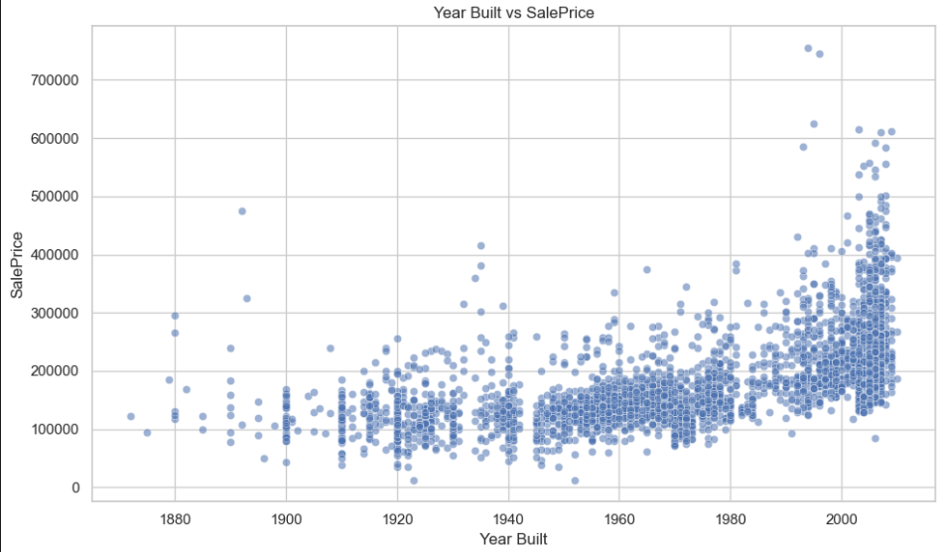

7. Correlation Analysis
A Pearson correlation matrix is calculated for selected numerical variables. A heatmap is used to make the direction and strength of relationships easier to interpret. The notebook also prints the correlations of Overall Qual and Gr Liv Area with SalePrice.
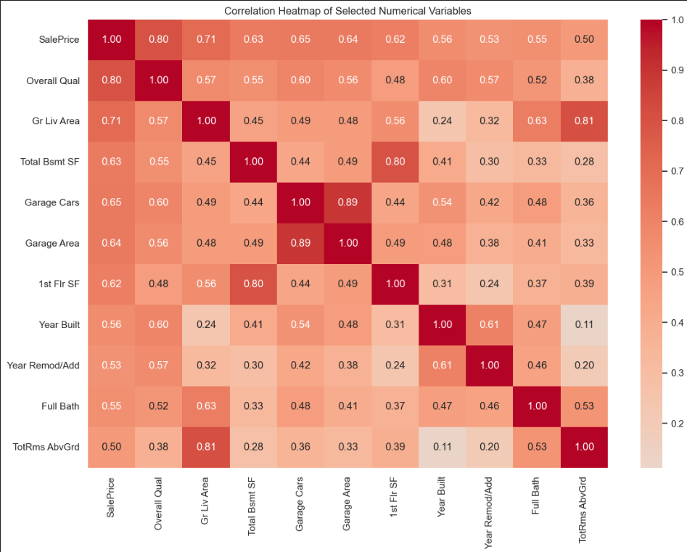

8. Expected Analytical Findings
The final observations must be written after executing the notebook so that the report reflects the actual generated results. The following categories should be covered:
- Shape and skewness of the SalePrice distribution.
- Variation and possible extreme observations in important numerical variables.
- Direction and strength of the relationship between major numerical features and SalePrice.
- Differences in SalePrice across Overall Quality categories.
- Differences in average SalePrice across neighborhoods.
- Important positive or negative correlations visible in the heatmap.
- Whether unusual observations appear to be valid extreme houses or possible data issues.

9. Week 4 Deliverables
Deliverable | File | Status
EDA notebook | EDA Deep Dive.ipynb | Prepared
Week 4 report | Week 4 Report.docx | Prepared
Visualizations | Generated by notebook | Run notebook before submission
Correlation matrix | week4_outputs/correlation_matrix.csv | Generated by notebook
Prepared dataset | week4_outputs/AmesHousing_Week4_Prepared.csv | Generated by notebook

10. Conclusion
Week 4 completes the EDA stage by moving from basic inspection and cleaning to systematic univariate and bivariate analysis. The generated distributions, comparative plots and correlation analysis provide a structured understanding of the dataset and create a foundation for deeper project-level analysis.

